BEST HTML5 SITES OF 2019

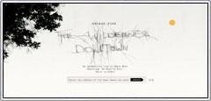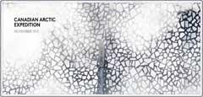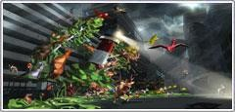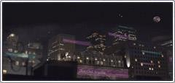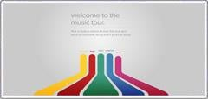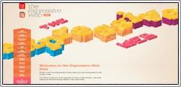

# The Wilderness Downtown

The Wilderness Downtown is an interactive music video for Arcade Fire's song ''We Used to Wait''. Visitors are asked to input the address of the home they grew up in and then the site uses Google Earth and HTML5 to create a personalized music video that takes the user on a journey back home.

# Heart of The Artic

Heart of The Arctic takes users on an Arctic expedition/scavenger hunt through four distinct environments designed to show users the steps that would be needed to restore climate balance to the arctic region. This site perfectly showcases how Html5 can be used to create fun and educational websites.

# Three Dreams of Black

3 Dreams of Black uses HTML5 to promote Danger Mouse and Daniele Luppi's album Rome. The site creates a 3D interactive world using WebGL where all the objects in the video react to both the music and user inputs. The site will make you feel as if you've EXPERIENCED the song and not simply listened to it.

# Enjoy Your Privacy

The website was created to warn consumers about the dangers of not using password protection on their mobile devices. This is done by using Html5 to produce a second-screen experience that will truly scare those that hitherto have avoided password protecting their mobile devices. So protect yourself.

# Google Play Music Tour

Google here uses Html5 to showcase the many features of its Google Play streaming music service. This is one of the prime examples of how the integration of video, sound, and interactive graphics can be brought together with Html5 to create an exciting and fun product promo that can drive consumer usage.

# Soul Reaper

A scroll activated digital comic book developed by Saizen Media uses HTML5 to breathe some new live into the presentation of graphic stories. The added motion and pacing makes the static images and story seem to come alive in a way that seems to be a bridge between old comics and video.

# The Expressive Web

Adobe created the Expressive Web website to highlight the functionality and creative potential offered through the use of HTML5 and CSS3. Through various examples and code snippets this is truly the best ''advanced'' HTML5 user guide we've seen. This site should be bookmarked by all HTML5 developers.

**Design by : MUHAMMAD SAMI ULLAH**